Name:_______________________
2nd Quarter Benchmark Review
I. Write an equation and solve.
1. Suppose you have $40 and earn $7 per hour. How many hours must your work until you have $131?
2. John’s car needed work. The mechanic charged him $140 for parts plus $48 per hour for labor. If the bull totaled $260, how many hours of labor were required?
3. The product of ¾ and a number is 3/5.
4. The sum of 6 and a number is 2.
II. Solve the equations.
5. x + 18 + 3x = 74

6. 14n + 2 – 7n = 37

7. 5( x – 4) = -30

III. Solve and graph the inequalities.
8. $\frac{x}{5}$ – 15 ≤ 10

9. -2r + 5 ≥ 19

10. 5x + 6 – x > -14

IV. Solve.
11. Mrs. Smith spent $23 on a manicure. She wanted to leave a 15% tip. How much is the tip? How much is her total bill?

12. Jonie paid $10.70 for 10 gallons of gasoline. Andy paid $15.60 for 12 gallons of gasoline. Who paid a higher price per gallon?

13. Find the price per ounce.

Ounces of coffee | Price
6 | $2.10
8 | $2.80
16 | $5.60
18 | $6.30

14. Oliver reads 28 ½ pages of a book in 1 $\frac{1}{6}$ hours. Express his reading speed in pages per hour.
15. On a trip your family wants to travel at least 420 miles in 8 hours of driving. Write and solve an inequality to find what your average speed must be.

16. A tree casts a shadow of 8 feet long. A 6 foot man casts a shadow of 4 feet. How tall is the tree?

17. The scale on a map is 2cm = 15 miles. Find the actual distance for a map distance of 6cm?

18. Find X.
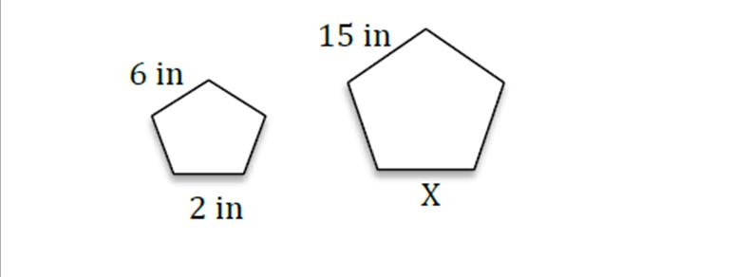
19. Find X.
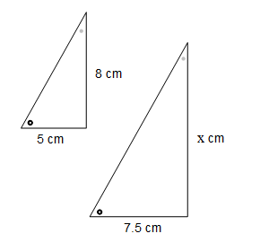
20. Mary saved $17.50 in the past 3 weeks. At this rate, how much will she save in 15 weeks?

