- Know the following explorers and what they’re known for:
- Christopher Columbus-
- Ferdinand Magellan-
- Henry the Navigator-
- Vasco da Gama-
- Bartolomeu Dias-
- Amerigo Vespucci-
- Hernan Cortez-
- Francisco Pizarro-

- What are the (3) motivating factors for exploration?
-Why are these factors important?
- What was the Columbian Exchange?
- Why was the Columbian Exchange important?
- Be able to list at least 3 items traded (in both directions) in the Columbian Exchange on the map below in their appropriate location
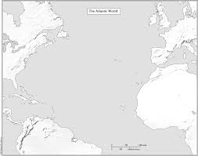

- What is colonization?
- What is exploration?
- How is colonization and exploration connected?

- Be able to draw at least 2 explorers routes (BE SPECFIC) on the map below and label the following:
- New World f) Africa
- Old World g) Europe
- Latitude line
- Longitude line
- North America
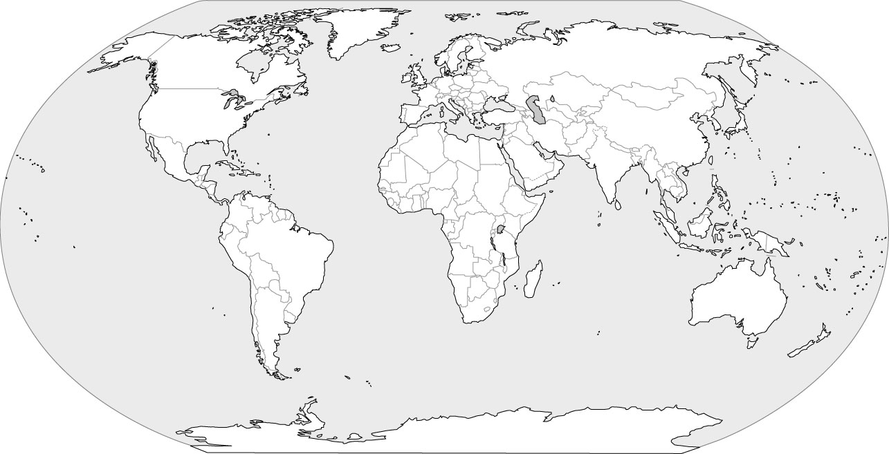

- Be able to read a quote and relate it to a topic we have discussed in class, examples below

“The seams of Pangaea were closing, drawn together by the sailmaker's needle. Chickens met kiwis, cattle met kangaroos, Irish met potatoes, Comanches met horses, Incas met smallpox—all for the first time."
Topic: ________________________________________

“Those new regions [America] which we found and explored with the fleet . . . we may rightly call a New World . . . a continent more densely peopled and abounding in animals than our Europe or Asia or Africa; and, in addition, a climate milder than in any other region known to us.”
Topic: ________________________________________

“I and my companions suffer from a disease of the heart which can be cured only with gold.”
Topic: _________________________________

“Following the light of the sun, we left the Old World”
Topic: ______________________________________________

- Know the definitions for:
- King Ferdinand and Queen Isabella Caravel Conquistador
- Natural Resources Circumnavigate
- Scurvy Middle Passage
- Geography Transatlantic Slave Trade
- Colony Encomienda System
- Caravel
- Circumnavigate
- Middle Passage
- Transatlantic Slave Trade
- Triangular Trade Route
- Encomienda System
- Conquistador

